Possessive Noun

🔹 What is Possessive Noun
# Source: AI Source: Provided by: [Data Path: Persons Table -> ID Column: 1, Name_En Column: Motasem Essam] -> From: [Chatgpt (GPT-4-turbo)] on [7/26/2025]
A possessive noun shows ownership, possession, or a relationship between one thing and another.
✨ It tells us that something belongs to someone or something else.

✅ Definition:
# Source: AI Source: Provided by: [Data Path: Persons Table -> ID Column: 1, Name_En Column: Motasem Essam] -> From: [Chatgpt (GPT-4-turbo)] on [7/26/2025]
A possessive noun is formed by adding apostrophe + s (’s) or just an apostrophe (’) to a noun to indicate who or what owns something.

🧱 How to Form Possessive Nouns:
# Source: AI Source: Provided by: [Data Path: Persons Table -> ID Column: 1, Name_En Column: Motasem Essam] -> From: [Chatgpt (GPT-4-turbo)] on [7/26/2025]
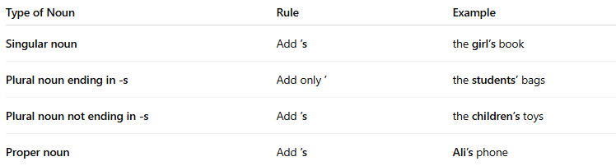
Type of Noun | Rule | Example
Singular noun | Add ’s | the girl’s book
Plural noun ending in -s | Add only ’ | the students’ bags
Plural noun not ending in -s | Add ’s | the children’s toys
Proper noun | Add ’s | Ali’s phone

📝 Example Sentences:
# Source: AI Source: Provided by: [Data Path: Persons Table -> ID Column: 1, Name_En Column: Motasem Essam] -> From: [Chatgpt (GPT-4-turbo)] on [7/26/2025]
- That is Sara’s notebook.
- The dog’s tail is wagging.
- All the players’ uniforms are clean.
- The children’s voices filled the hall.

🎯 Possessive Noun vs. Plural Noun:
# Source: AI Source: Provided by: [Data Path: Persons Table -> ID Column: 1, Name_En Column: Motasem Essam] -> From: [Chatgpt (GPT-4-turbo)] on [7/26/2025]
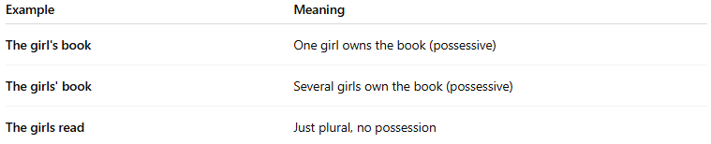
Example | Meaning
The girl's book | One girl owns the book (possessive)
The girls' book | Several girls own the book (possessive)
The girls read | Just plural, no possession

🔄 Possessive Noun vs. Possessive Pronoun:
# Source: AI Source: Provided by: [Data Path: Persons Table -> ID Column: 1, Name_En Column: Motasem Essam] -> From: [Chatgpt (GPT-4-turbo)] on [7/26/2025]
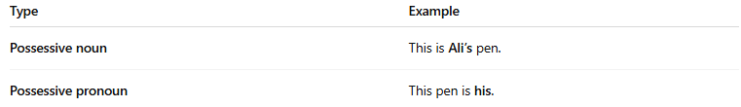
Type | Example
Possessive noun | This is Ali’s pen.
Possessive pronoun | This pen is his.

✅ Summary:
# Source: AI Source: Provided by: [Data Path: Persons Table -> ID Column: 1, Name_En Column: Motasem Essam] -> From: [Chatgpt (GPT-4-turbo)] on [7/26/2025]
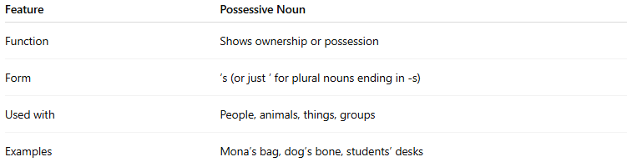
Feature | Possessive Noun
Function | Shows ownership or possession
Form | ’s (or just ’ for plural nouns ending in -s)
Used with | People, animals, things, groups
Examples | Mona’s bag, dog’s bone, students’ desks

